2.9. - STANDARD DETAILS

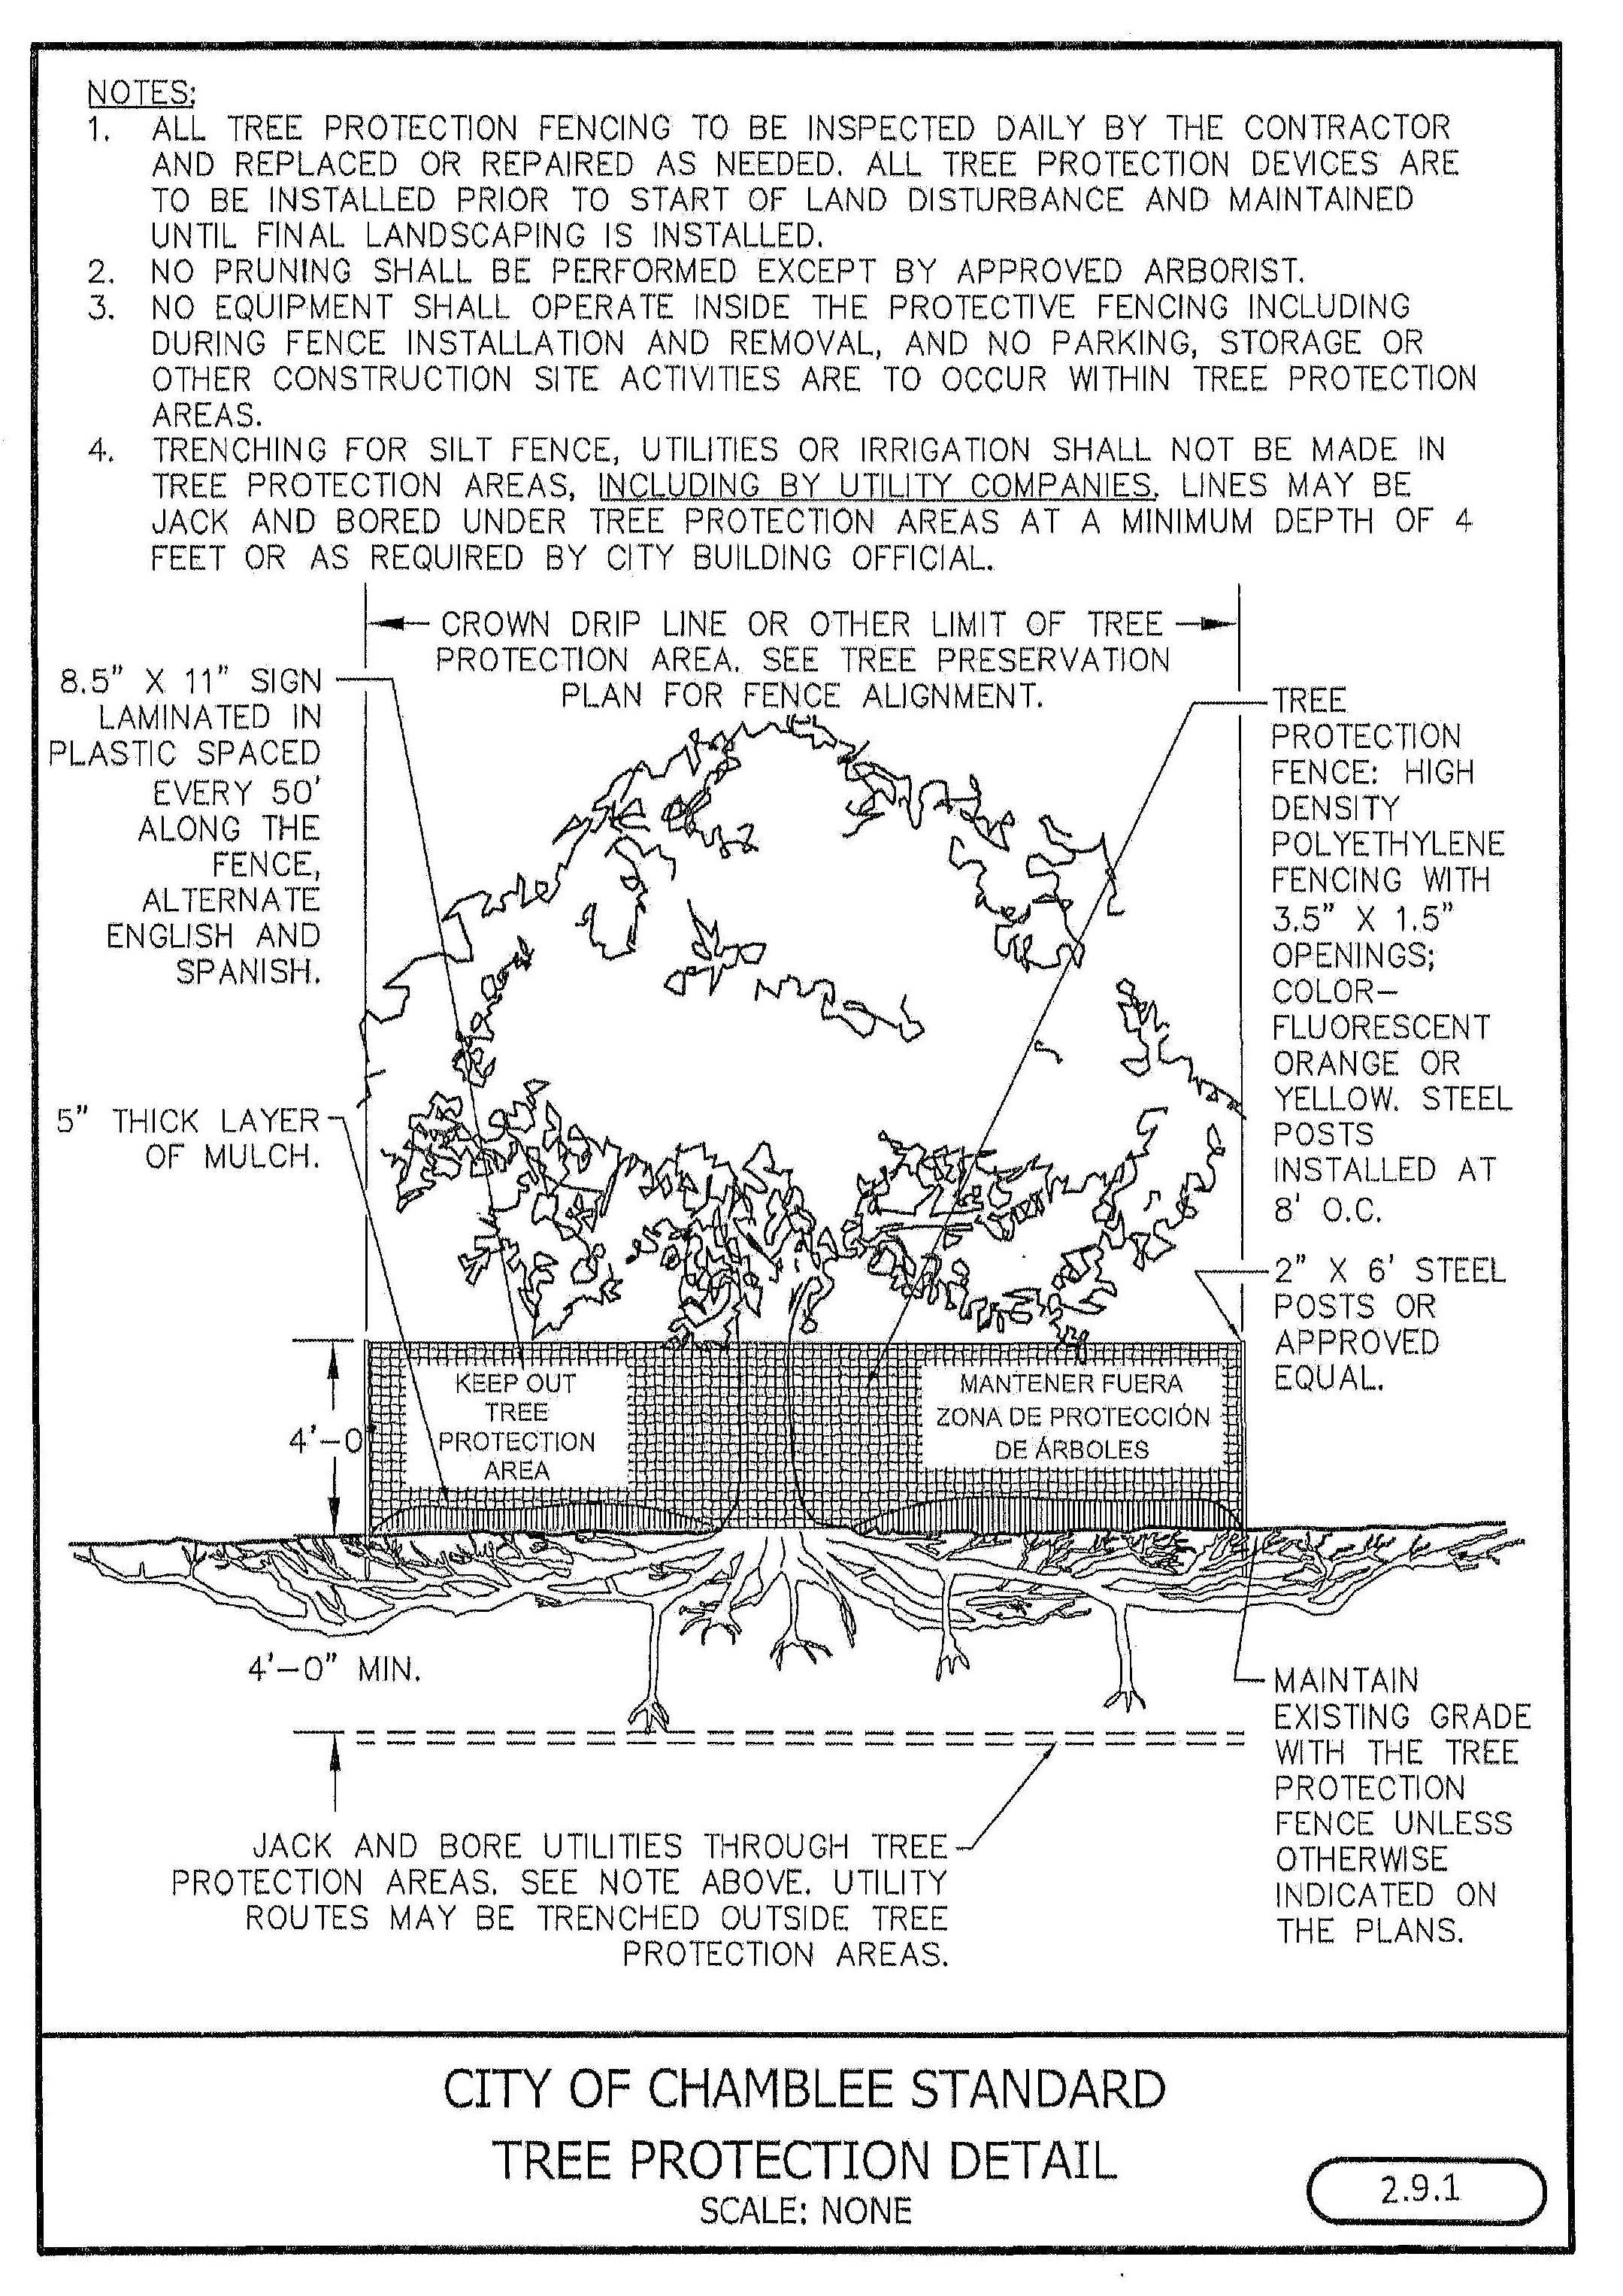

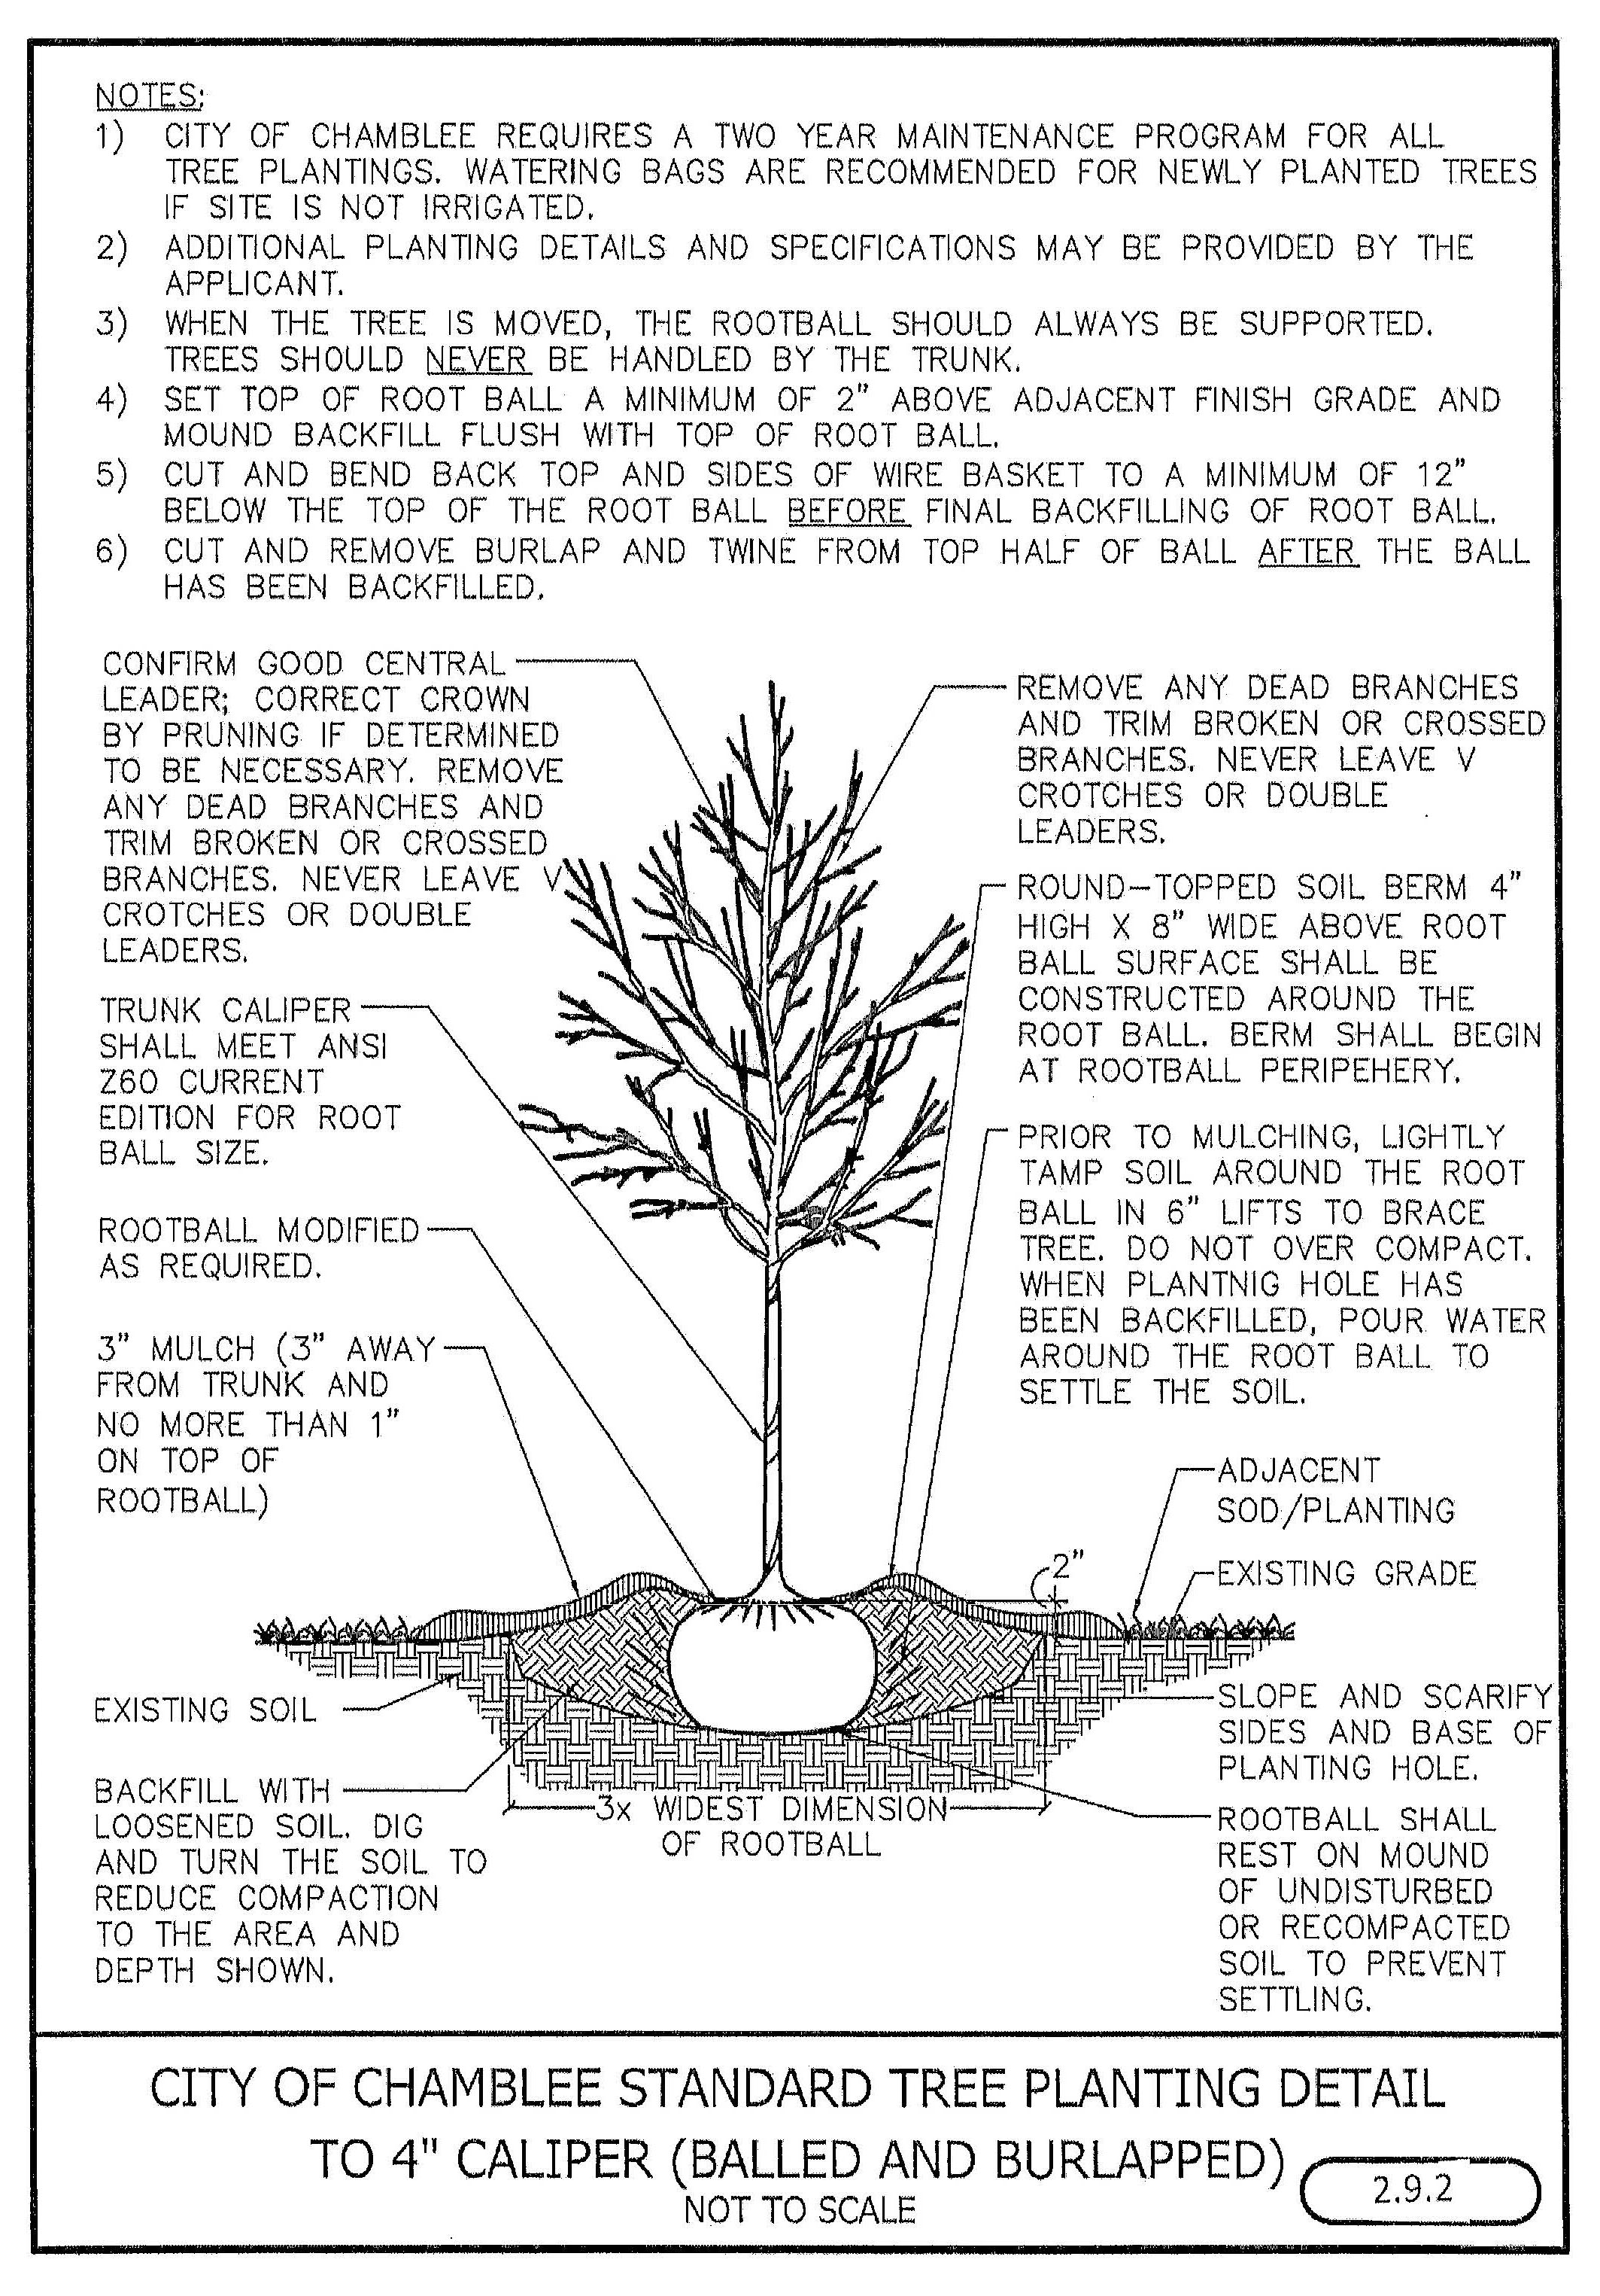

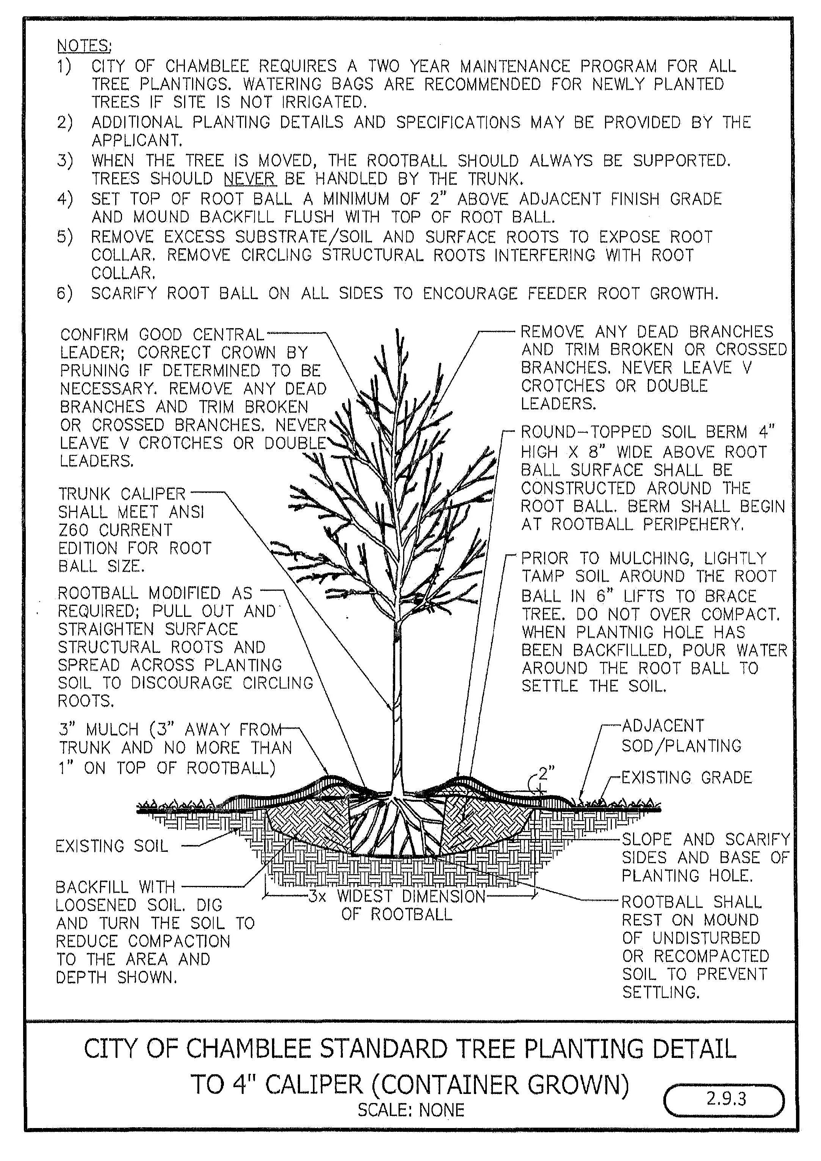

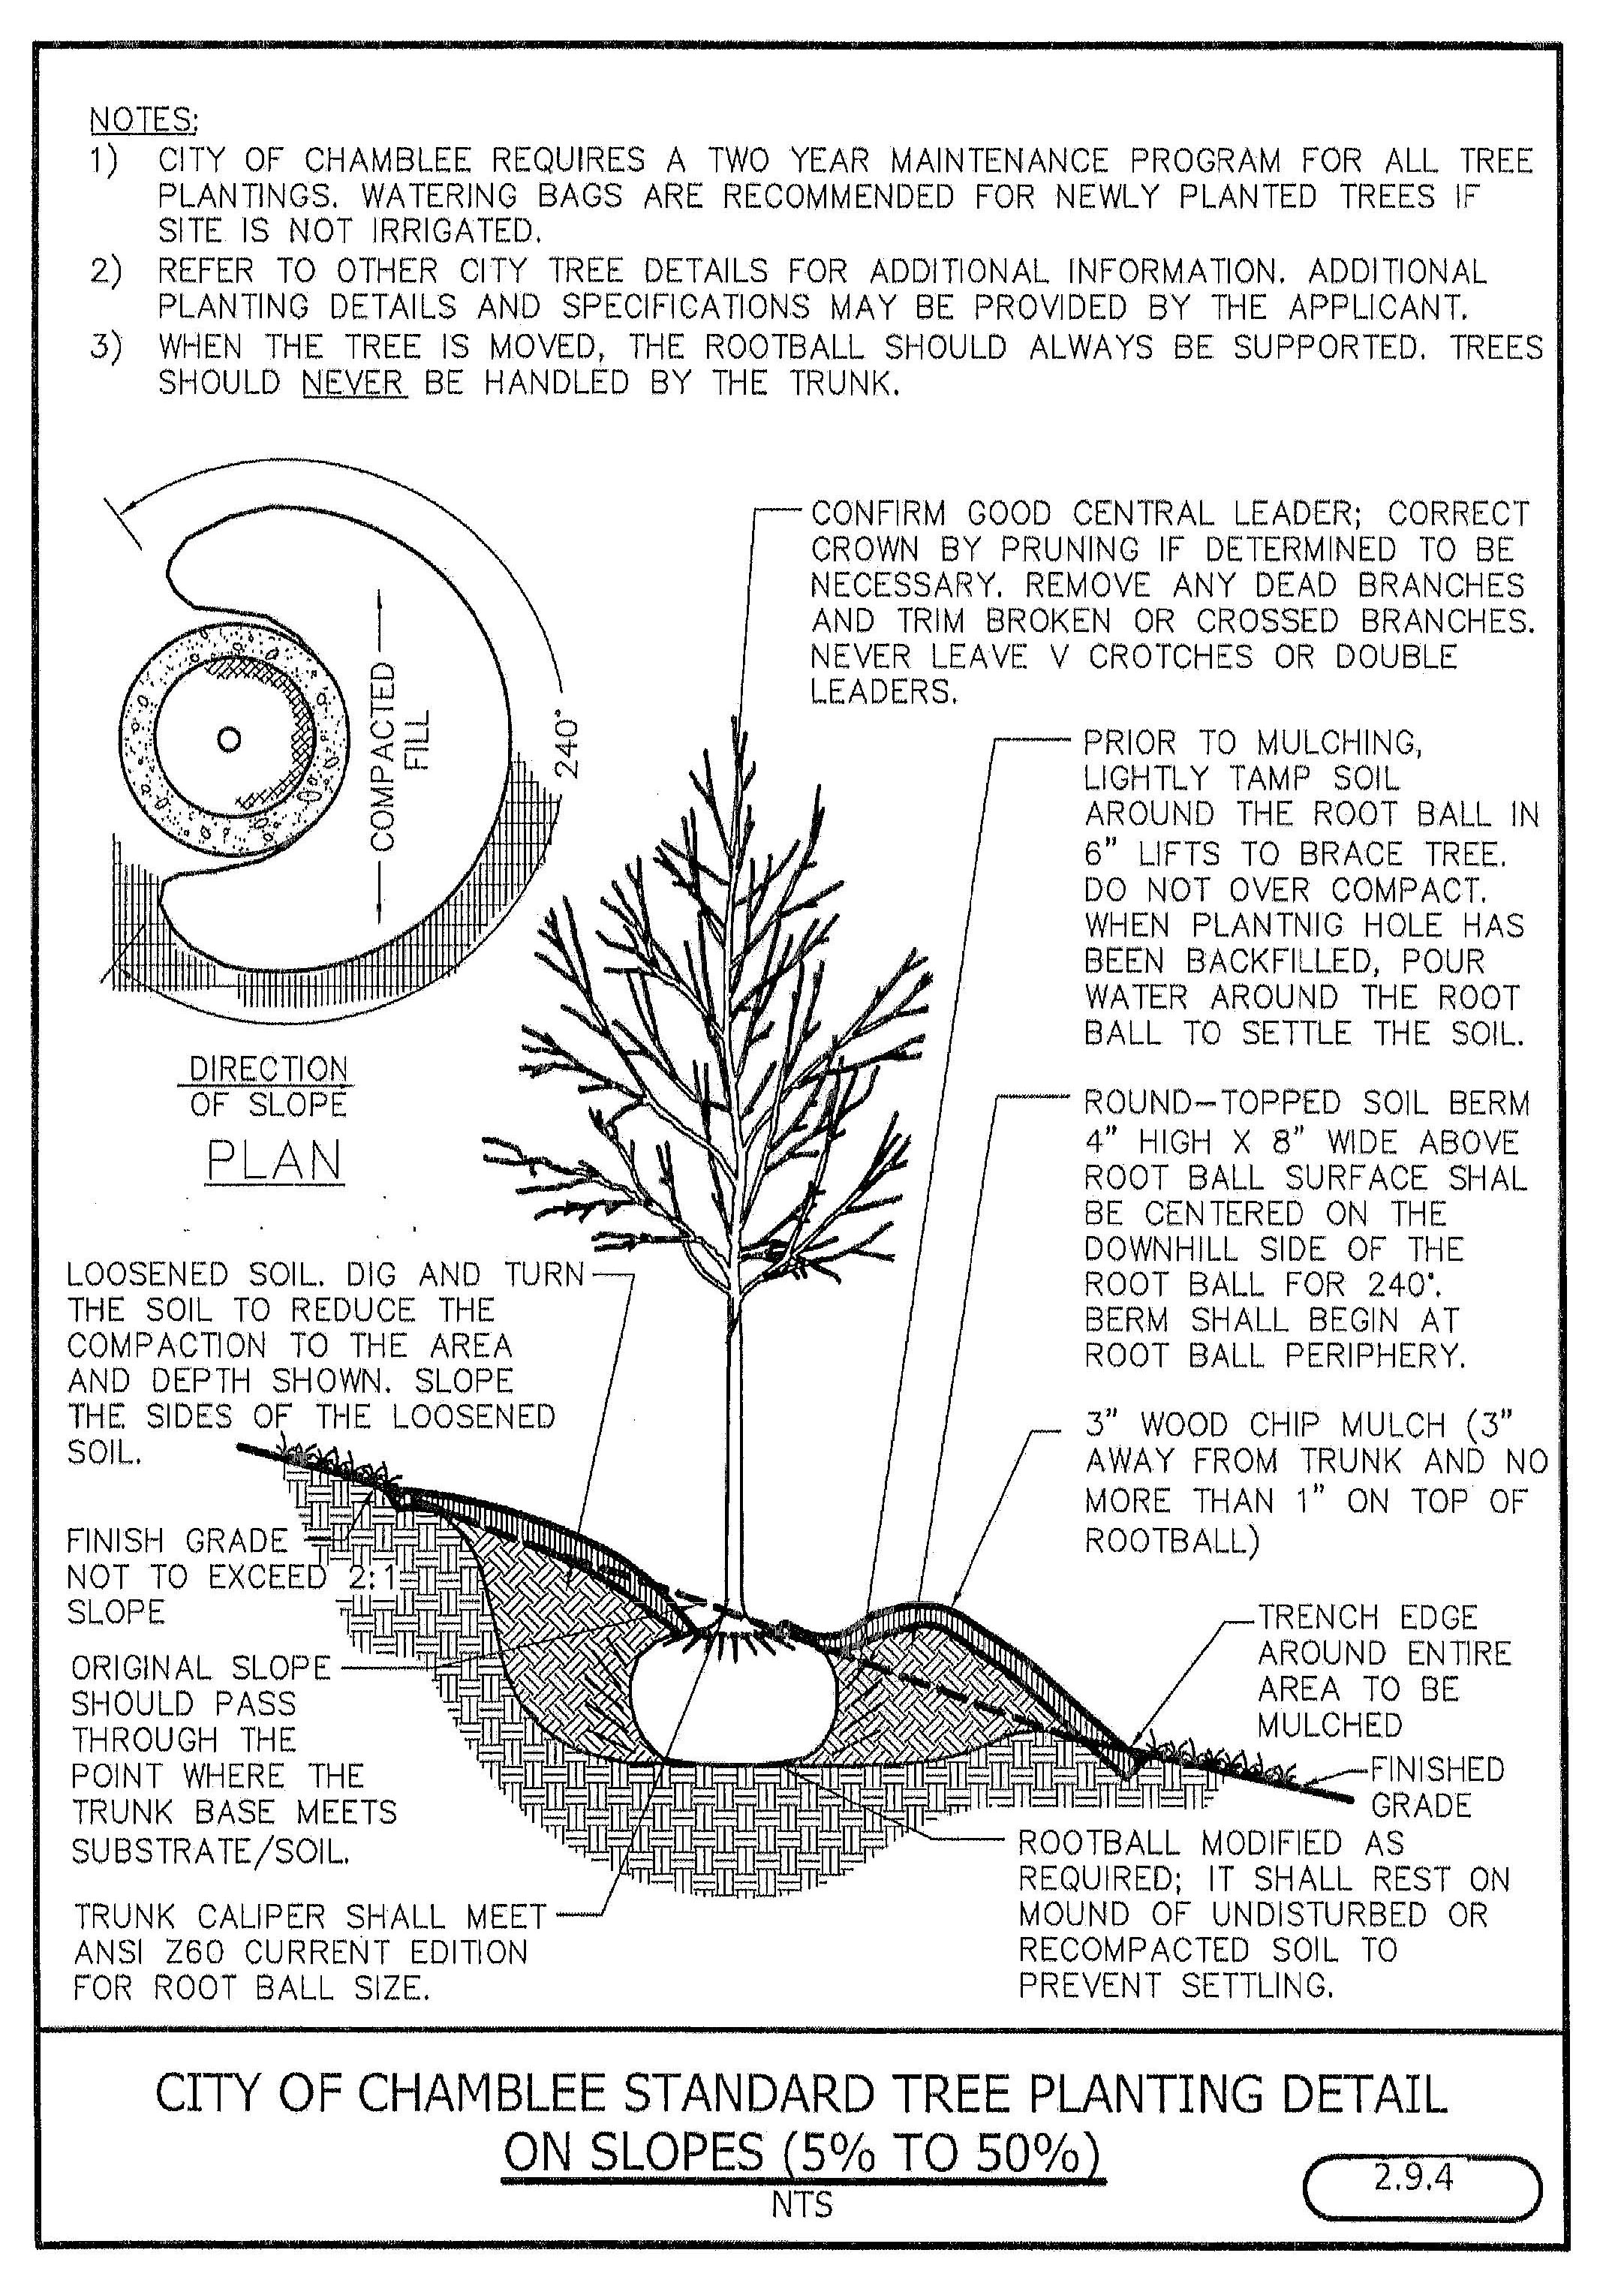

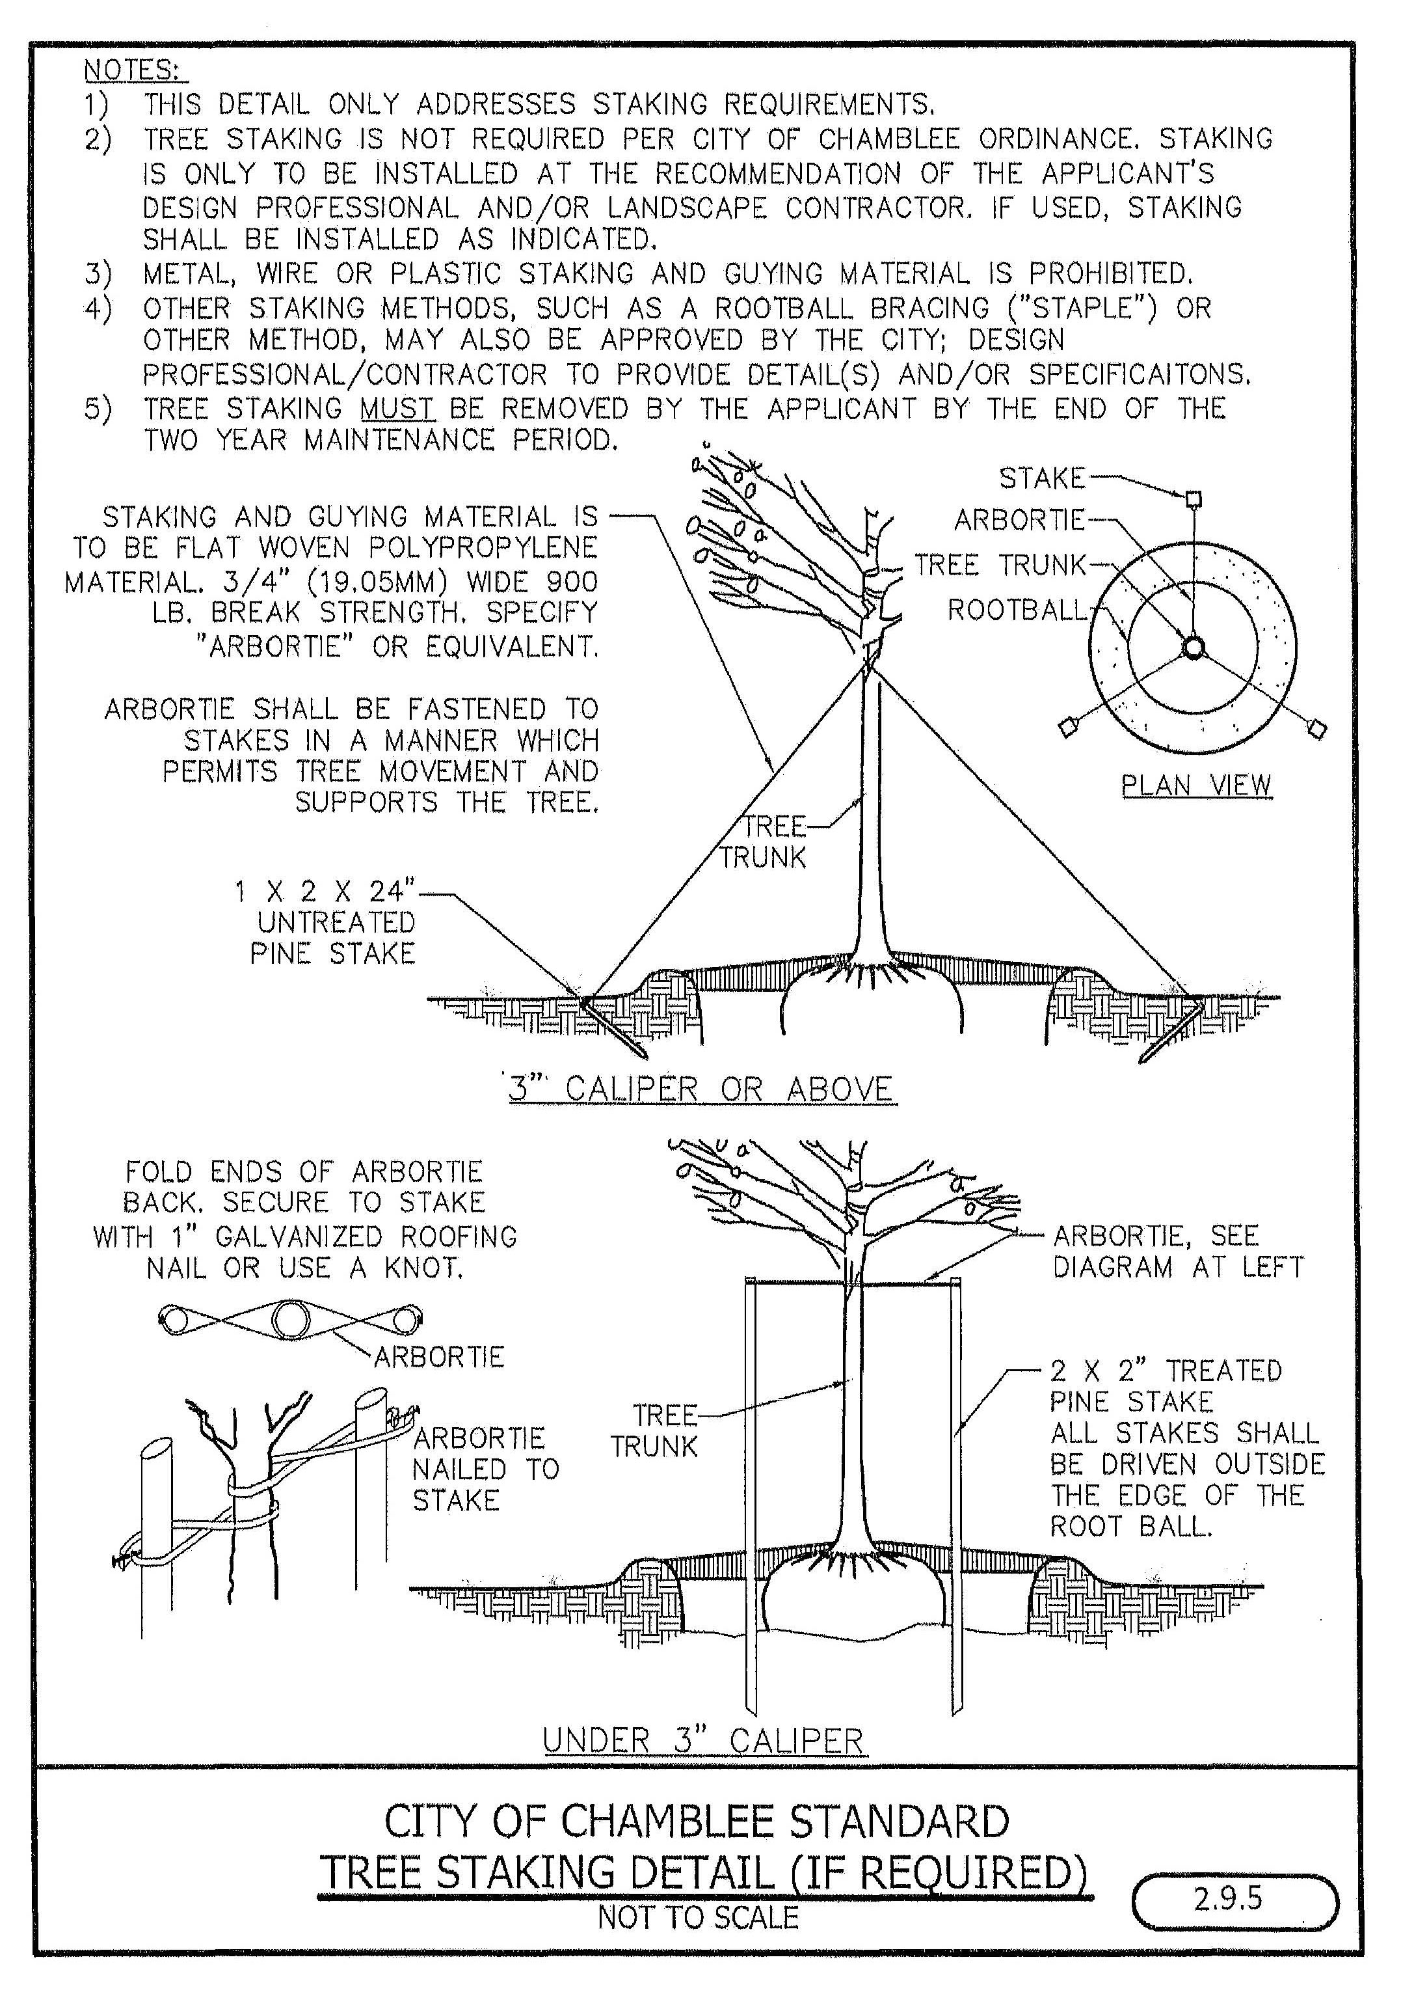

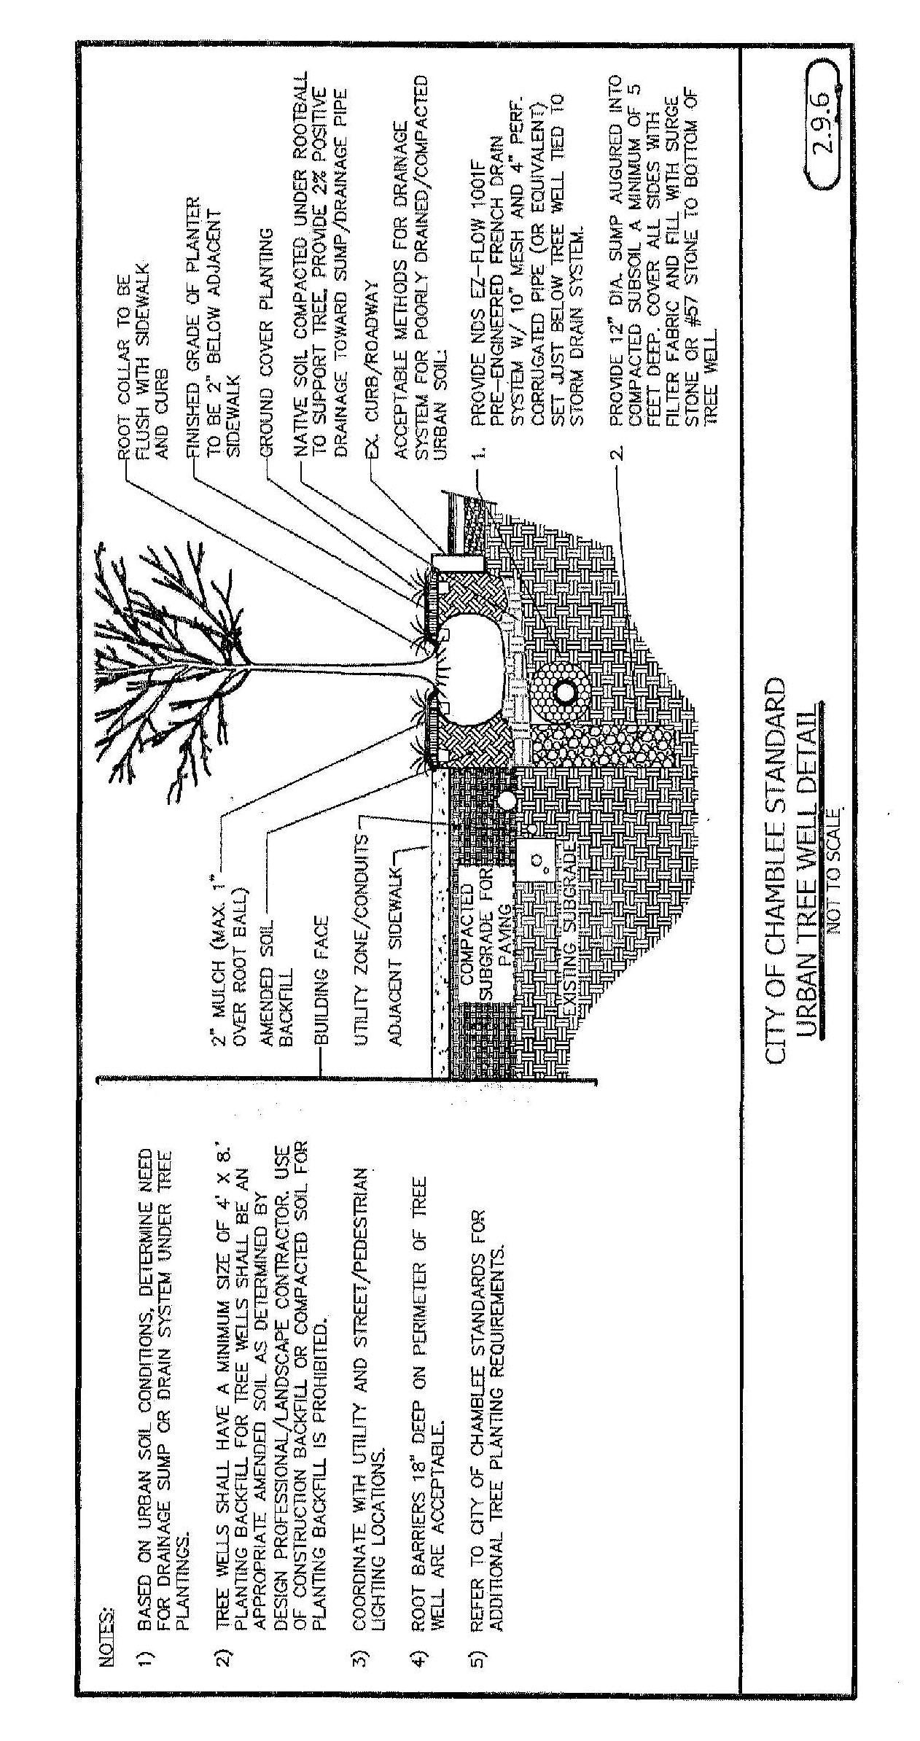

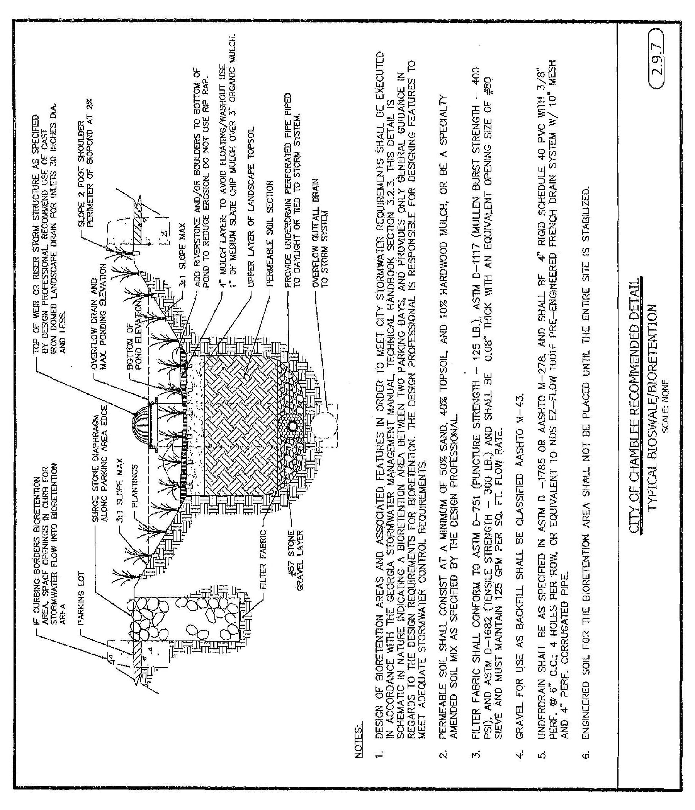

[] 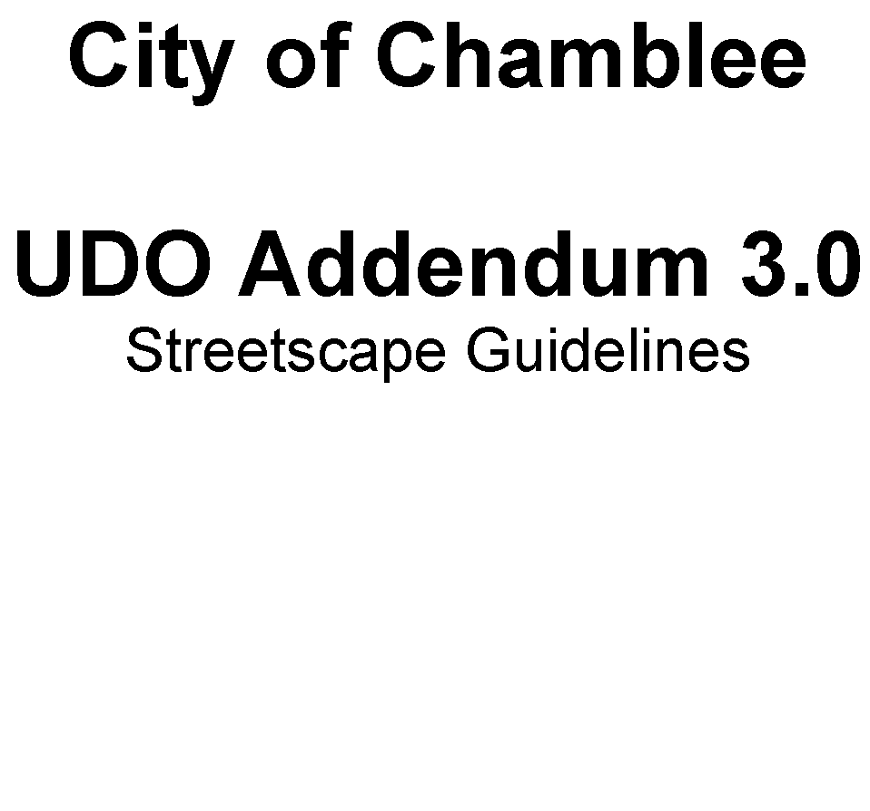

June 11, 2015

**Preface**

In December 2008, the City of Chamblee adopted Streetscape Guidelines in order to assist with the administration and enforcement of the City of Chamblee's Code of Ordinances as they related to streetscape improvements within the public rights-of-way. With the preparation of the draft Unified Development Ordinance in 2014 these Guidelines were updated to match the terminology and standards of the draft code and new Comprehensive Plan. In 2017, several of these recommendations were incorporated into the UDO. What follows are the administrative guidelines to be considered during the permitting process in coordination with Chapter 350 requirements.

**Table of Contents**

|  |  |
| --- | --- |
| 3.1. Street Designations ..... | 5 |
| 3.2. General Notes ..... | 7 |

Footnotes:

--- () ---

**Editor's note—** Addendum 3.0 has been amended by the following: Ord. No. 710, pts. I—V(Exhs. B—F), 7-19-16; Ord. No. 743, 12-19-17.

3.1. - Street Designations

In accordance with the Unified Development Ordinance (UDO), the dimensions of all landscape zones, sidewalks, minimum building façade heights and front yards are governed by the street designation that the lot fronts on, in order to ensure consistency and application of the streetscape requirements. The street designations of all public streets are defined in Chapter 350 of the UDO, and are illustrated in the City of Chamblee Comprehensive Plan on the "Streetscape and Gateways Map." A reduced copy of this map is on the following page, and a poster sized copy of the map is available on the city website at www.chambleega.gov.

In addition to public streets, the city also allows private streets, which may follow the same designations as the public streets or one of two other typologies: alleys and narrow streets. These private streets are not shown on the Streetscape and Gateways Map, and must be approved under the provisions of the UDO.

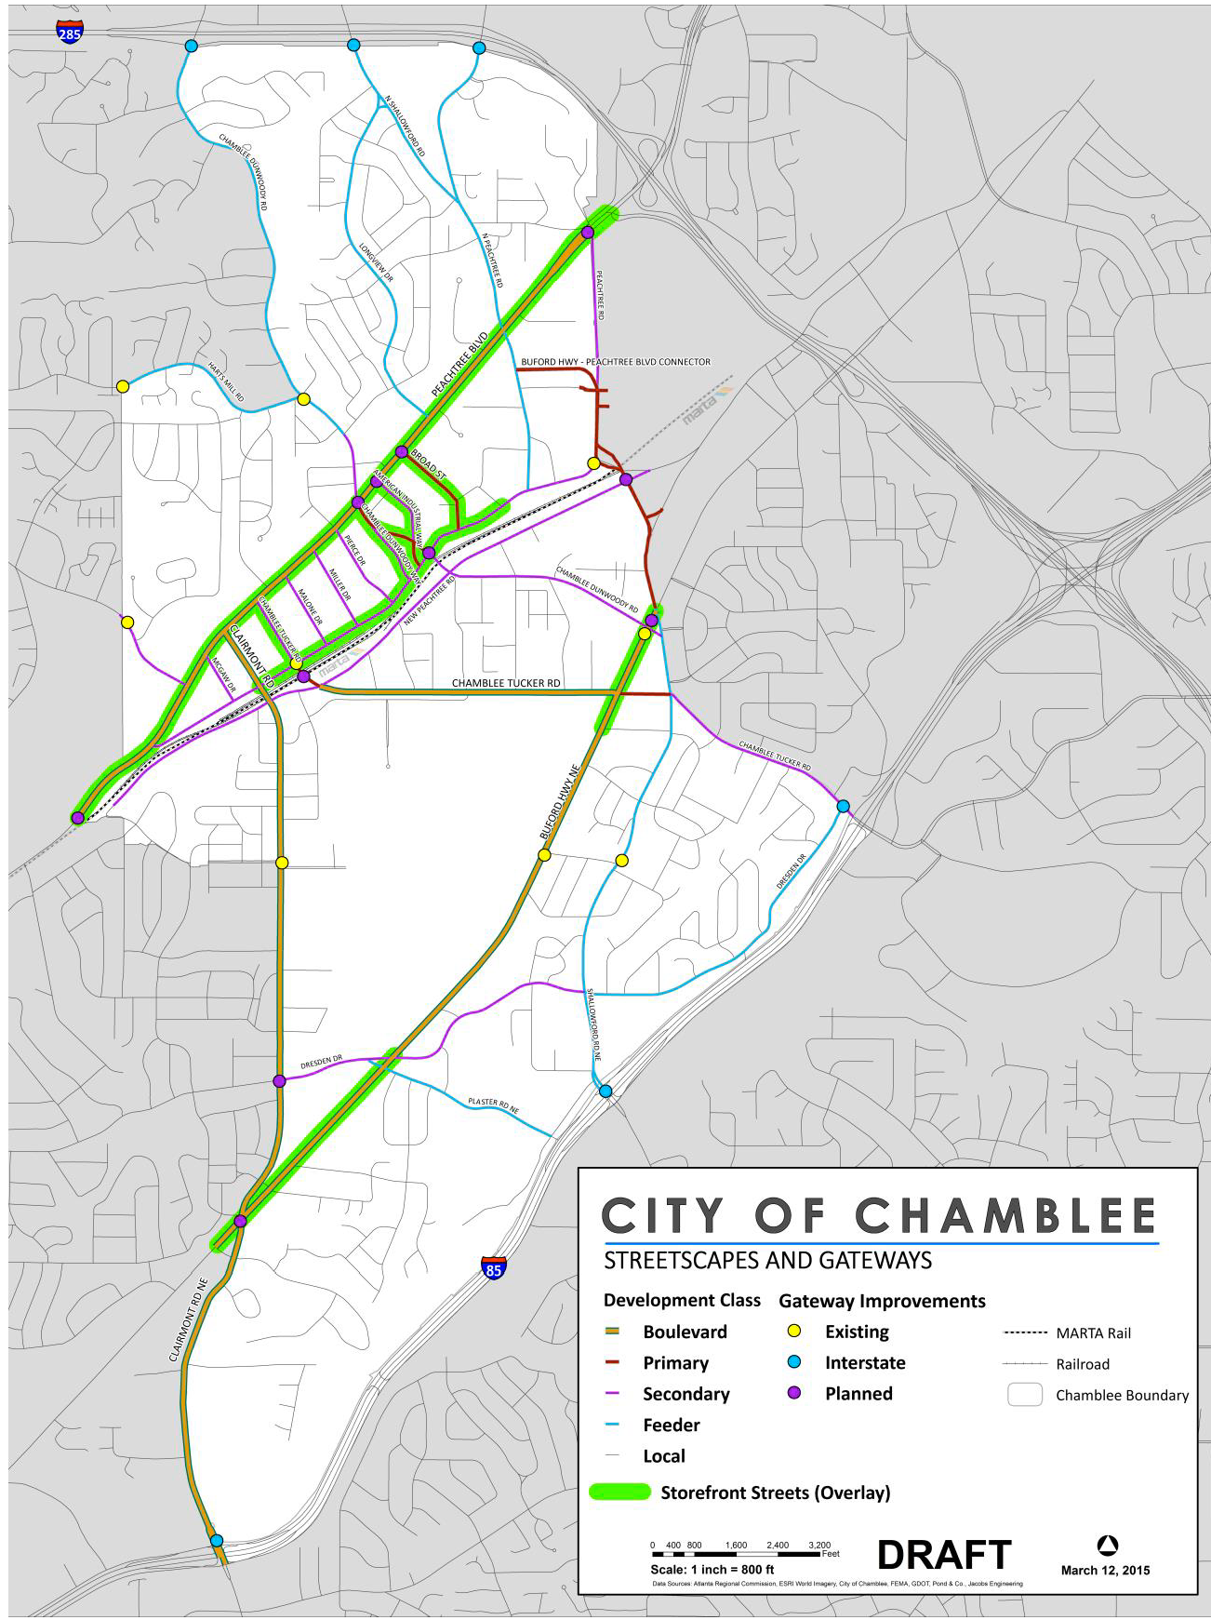

3.2. - General Notes

(a)  Current Americans with Disabilities Act (ADA) standards shall apply to the design and installation of all pedestrian facilities (e.g., sidewalks, ramps, crosswalks).

(b)  Street trees pre-approved for installation in the landscape zone, are listed in Addendum 2.0 of the UDO.

(c)  Retaining walls, where pre-approved for installation in the right-of-way, must be installed in accordance with the following specifications:

a.  All walls over 4 feet in height require engineering certification.

b.  Walls within limits of streetscape requirement are encouraged to be granite veneer masonry walls or granite rubble masonry walls as indicated by the following graphics:

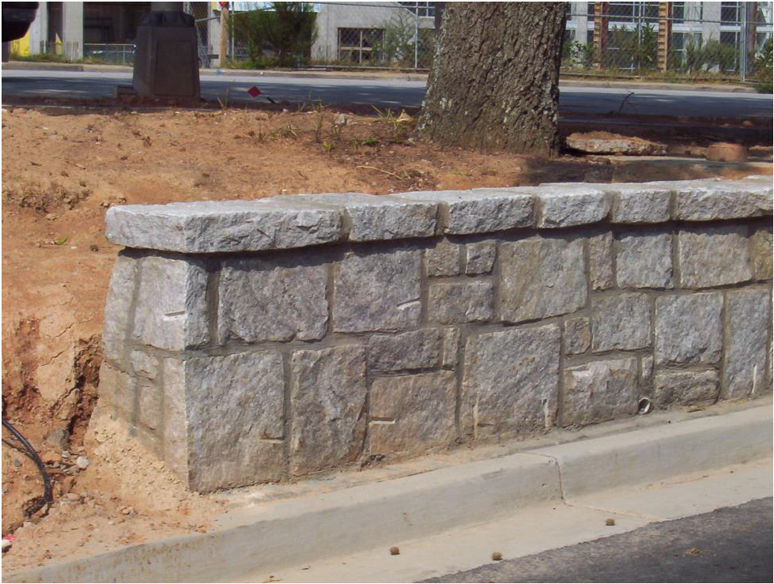

(d)  The following style of segmental block wall is acceptable without City review: BelAir by Belgard. *http://www.belgard.com/products/retaining_walls/belair_wall*

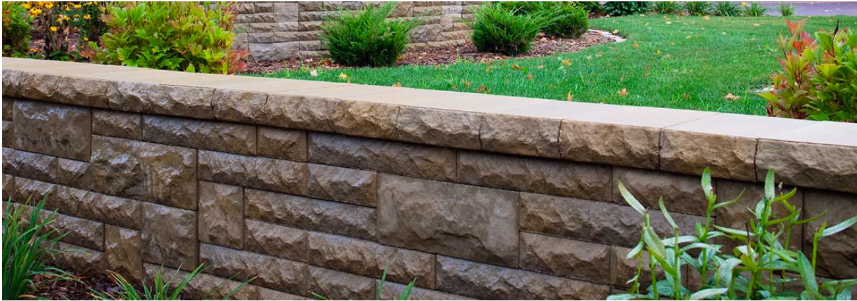

(e)  Other styles of segmental block or other masonry may be approved on a case by case basis.